**Task 1: Definitions and Descriptions (25%) (Autumn 2011)**

1. Give a definition or description for the following items: Kinematic Model, Static Model, Dynamic Model

|  |
| --- |
| **2-Static model**  -Evaluation of two static movements under different acting forces  -Time IS NOT considered  **3-Kinematic model**  -Geometric movements of individual points are described in a time-dependent way.  -More than two epochs considered.  **4-Dynamic model**  -Geometric movement on time-dependent acting forces. |

**Task 2: Modelling of Moving Objects (50%) (Autumn 2011)**

1. To describe dynamic systems models are often used which are distinguished according to their number of inputs and outputs. Describe two of these dynamic models in a sketch in general and give one example for each model in reality.

|  |  |
| --- | --- |
|  | Ex for SISO: Cruise Control or Audio Device  Ex for MIMO: Large Modern Telescopes |

1. One important part in a closed-loop system is the description of the controlled system (plant). In general, for the description of vehicle movement the well-known one-track model is used. Describe the geometric relationship of this model considering the slippage. Use a sketch and name all important variables and equation for the computation of the radius and the side slip angels.

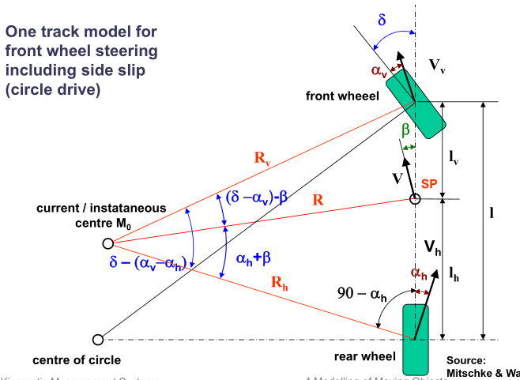

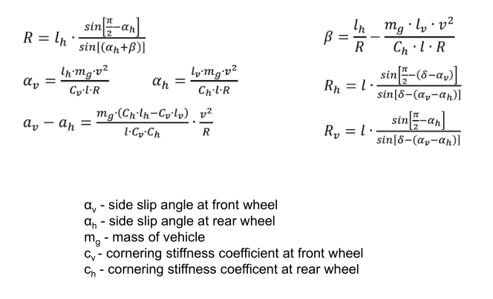

1. Kalman filters are often used in control loops. Name two reasons, why they are used and write down the equation of prediction for this filter. Name all used matrices and vectors.

|  |  |
| --- | --- |
|  | Corrects the predicted value using the measured value, so it convolves to a mean value without using so many iterations. |

Task 3: Construction Machine Guidance (25%) (Autumn 2011)

1. In general two kinds of classification systems exist for construction machines; one with regard to the degree of automation and another with regard to the number of dimensions. Please name the two classification systems and their sub-divisions and give short descriptions of all classifications and sub-divisions.

|  |
| --- |
| 1- Automation: describes the autonomy degree of the system  a-Indication/Guidance: only gives information on guidance to the driver, who steers the system.  b-Semi-automatic: controls height and slope of the system automatically, driver controls position.  c-Automatic: total automatic control of the system.  2- Dimension: describes the number of controlled parameters   1. 1D: controls height 2. 1.5D: controls height and slope 3. 3D: controls height, slope and position |

1. For a road construction task you have to use a robot tachymeter to control a grader. You know that the grader moves with a velocity of 30 cm/s. Please determine the maximum allowed delay time for the robot tachymeter. The maximum deviation for positioning should not exceed 0.5 cm.

|  |
| --- |
| v=d/t=0.5/30=0.0166s |